**Because I was getting some really high error values, if any went above 10 I set them to 10 so that the y axis scale in final graph made sense. So value of 10 on graph means value was 10 or higher.**

**Params_Go for lowest chi square value so far:**K_facGo = 0.004

Pre_t_mean = 0.19

Pre_t_sd = 0.02

Tau_facGo = 1.45

Inhib_tonic = 1.61

Inhib_sd = 0.14 ** but error function would suggest this isn’t global minimum

**K_facGo** - range 0.001 : 0.010 (also ran range 0.001 to 0.1 – all rest inf error)

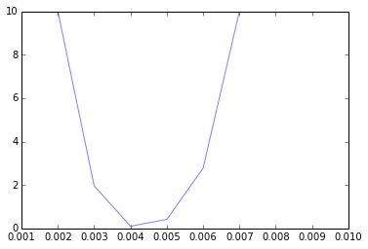

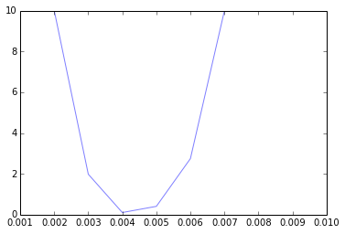

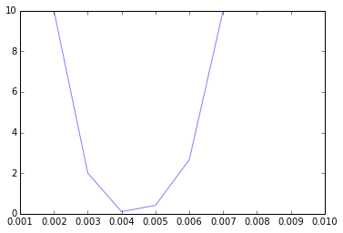

**Pre_t_mean** – range 0.01 : 0.5

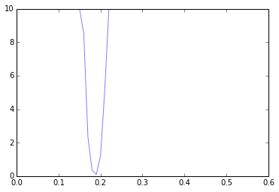

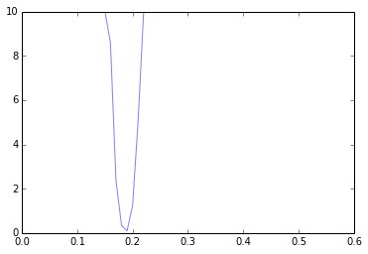

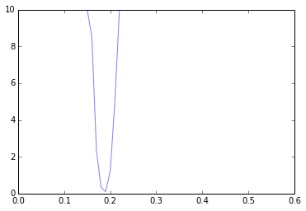

**Pre_t_sd** – range 0.01 : 0.5

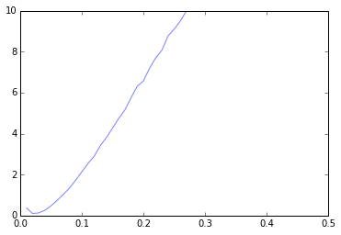

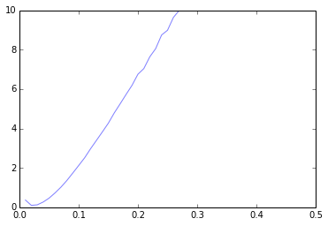

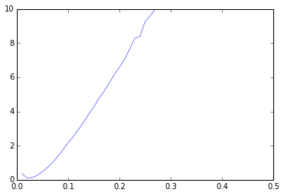

**Tau_facGo** – range 0.05 : 4.0

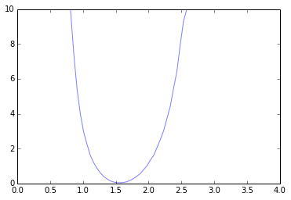

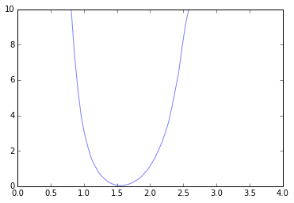

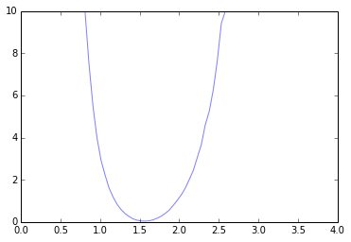

**Inhib_tonic** – range 0.05 : 3.0

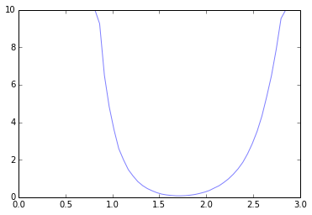

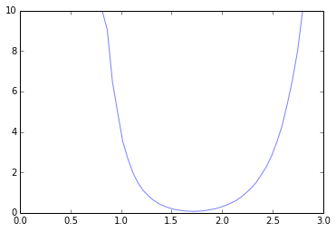

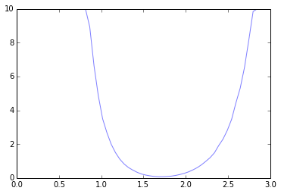

**inhib_sd** – range 0.02 : 2.0 * y axis very low for all values

